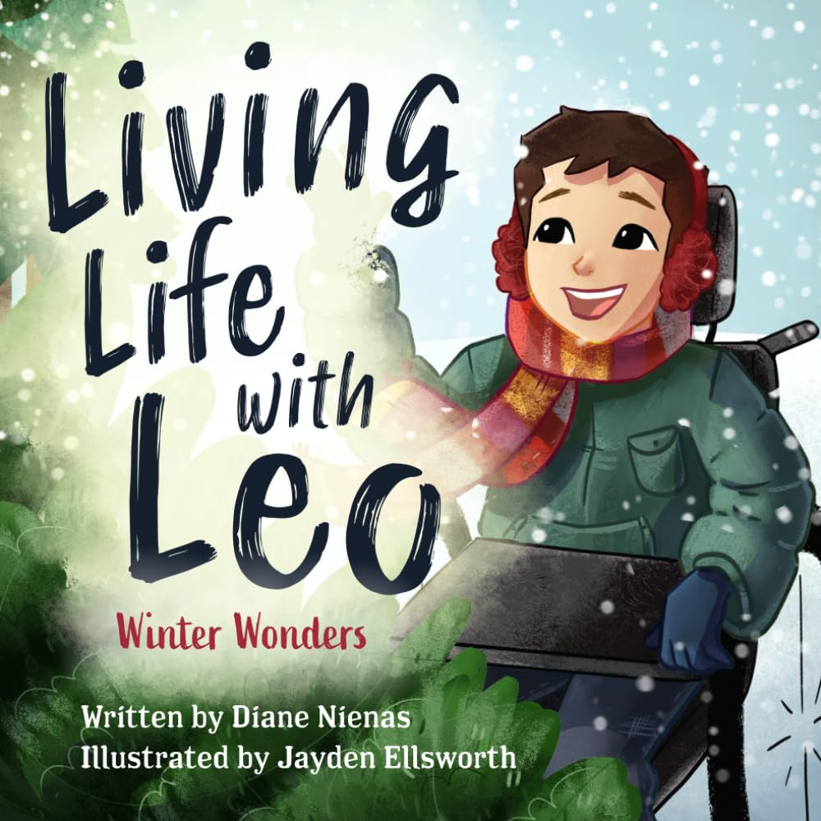
FRIDAY, December 1st - AUTHOR VISIT: Diane Nienas, Maple Alumni
Who is Diane? Diane Nienas is a three-time #1 Amazon best selling author, speaker, and grief coach with a degree in life experience. With two decades of caretaking for terminally ill children, Diane has learned how to navigate through many unforeseen circumstances with grace. Diane is instrumental in advocating for people with special needs, often bringing together influential members of the community to ensure good deeds are accomplished. As a member of several groups, Diane is a voice for the unheard by being a champion for women as well as serving others to enhance their quality of life.

Diane was raised on a farm in Southeastern Wisconsin, one of 15 children. She went on to marry her high school sweetheart, Tony, and raised four sons. Growing up she learned the value of simple living and instilled the gift of being in the moment into her own children. After the recent death of two of her sons, Diane now embarks on a new season of her life by spreading the seed of hope through sharing her story and breathing light into dark places.

School Visit Info: Encourage your students through storytelling. Diane’s interaction lessons of reading, writing, and imagination will teach children that everyone is special. Diane’s series Living Life with Leo will help children to KNOW that no limitation can keep a child from living a fulfilling life. Rhythm and rhyme will teach gentle truths on inclusion and kindness.

Kids’ will GROW to understand that what makes them unique is their differences. By exploring Leo’s adventures and seeking the hidden cardinal, students will discover they are capable and can be a light for someone in need.

Through a creative activity, children will leave with something to SHOW. Their work of art will allow them to remember the lessons learned and share the adventures of Leo with their special loved ones.

FRIDAY, December 1st - RIGHT TRACK: INTEGRITY + AUTHOR VISIT: Diane Nienas, Maple Alumni
Duration of her stay at Maple: 9:20-12:20
40 minutes time spot (30 presenting+questions)
Craft supplies and models will be prepared for each class.
Crafts will be completed in classrooms.
2 parent volunteers will be recruited per class. Daneille, JC, and Kim can fill in where we need people.
 | RIGHT TRACK  Assembly | Break | Author -Gym | Craft - Classrooms | Specials | Lunch
K | 9:20-9:40 | Go Noodle | 9:45-10:15 | 10:30-11:30 | PM | 11:30
1 | 9:20-9:40 | Go Noodle | 9:45-10:15 | McMahon 10:30-11:30  Greenwald, Kelly, Nethery  Start Craft 10:20-10:35, 11:30-12:10 | G,K,N 10:40-11:25 | 12:10
2 | 9:20-9:40 | Go Noodle | 9:45-10:15 | 10:30-11:20 | 11:25 | 12:25
3 | 9:20-9:40 | Back to class | 10:30-11:10 | Hill: 1:30 - 2:20  Fraundorf and Grove: 9:45-10:30 | Hill: 9:45-10:30(Tech) | 11:35
4 | 9:20-9:40 | Back to class | 10:30-11:10 | 9:45-10:30 | PM | 12:00

Nate will need help setting up the tables for lunch.

Appropriately

